
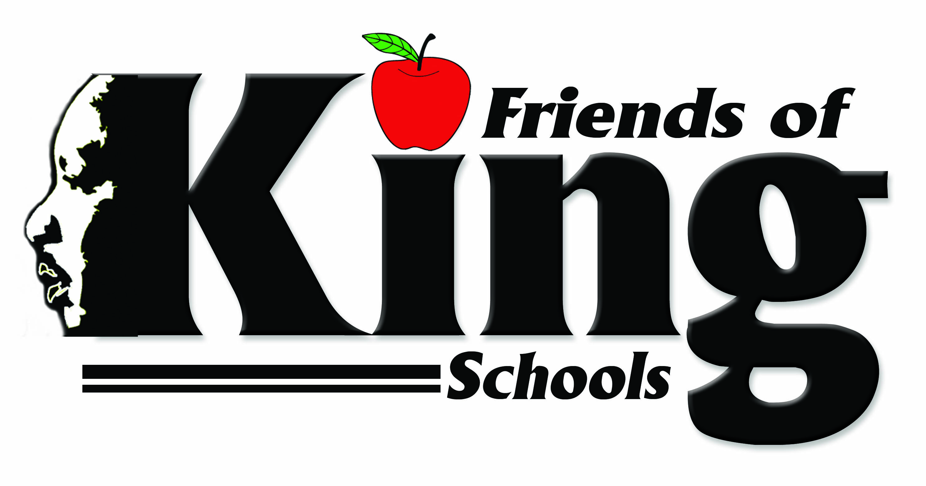

Greetings Future MLK Explorer Parent/Guardian,

Welcome to the Friends of King School District! I want to personally thank you for choosing to continue your child’s academic successes at Dr. Martin Luther King, Jr. Charter School for Science and Technology.

The MLK staff takes education very seriously and has high standards and expectations for all students that attend. At King School, there is an unwavering focus on student achievement, high levels of family and community involvement, safety, and building a strong network of support for students. It is an environment where parents can have a peace of mind knowing their child is being given the best every day! Also, know that the administrative team is always available to you, and I encourage you to contact them for any reason, at any time. The school’s office number is 504.940.2243.

MLK is a special place where everyone comes together as a family! The spirit, traditions, diversity, commitment to academic excellence, as well as the dedicated staff contributes to making MLK a great choice to continue your child’s academic successes.

Again, welcome to Dr. Martin Luther King, Jr. Charter School for Science and Technology and we look forward to you having a great MLK Explorer Experience!

Kingfully yours,

Gloria Miles, Director of Admissions

“Committed to the Community - Dedicated to the Dream”

