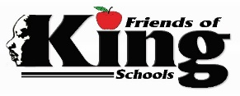
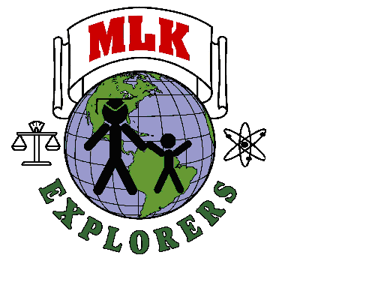
Dr. Martin Luther King, Jr. Charter School
- Pre-Kindergarten (LA-4 Program)
- Kindergarten

The upcoming 2022-23 school year is vastly approaching! Do you know someone that is looking to enroll their child in an outstanding early childhood, full-day program next year? Good News - We have PK-4 and Kindergarten seats available!
Dr. Martin Luther King, Jr. Charter School for Science and Technology offers a safe, high-quality Pre-K and Kindergarten education for 4- and 5-year-olds. We focus on building on your child’s earlier learning experiences, advancing his/her literacy, vocabulary, math, problem-solving, and fine and gross motor skills. These focus areas are all essential to readying our early childhood students for the next stage of learning and life. Our Pre-Kindergarten and Kindergarten programs are full day and in-person learning classes. Before and After-Care will also be available.
Our Pre-Kindergarten and Kindergarten Curriculum and Activities Include:
- Mastering Skills: We provide a well-rounded education that emphasizes physical, cognitive, and social-emotional development. Your child’s daily routine includes fun and challenging math, science, social studies, literacy, and physical activities.
- Building Confidence: Our early childhood students are incredibly inquisitive. They express their newfound independence through investigation, exploration, and increasing certainty. Our state-certified teachers provide our students with many choices throughout the day to choose from equipment, centers, and materials – helping to instill confidence in each child.
- Confidence and Choices: Early childhood students are learning to define the world they live in and their role in that world. Throughout the day our program provides many opportunities to make choices, which allows our students to navigate his or her surroundings throughout the day with confidence.
- Promoting Literacy: Our classrooms have a rich environment with words, language, and print which is the key to literacy. Our students participate in interactive learning to increase phonological and print awareness, reading and narrative skills, and letter knowledge. Writing skills are expanded with the use of journaling.
- Physically Fit: Learning good fitness and nutrition habits early can lead to a healthy lifestyle for years to come. Interactive exercises are a part of our daily routines and instilling the value of smart, healthy choices.

If you or ow did not participate in the Main Round and is looking
If you or anyone you know did not participate in the 2022-2023 Main Round of enrollment and is looking for a Pre-Kindergarten or Kindergarten seat at a school where parents can have a peace of mind knowing their child is being given the very best every day – please have them visit NOLA Public School’s website by logging into https://oneapp.secure.force.com/ and choose Dr. Martin Luther King, Jr. Charter School for Science and Technology – Where Dreams Begin, Preparing the Next Generation.

For more information about our Pre-Kindergarten (LA 4 Program) or Kindergarten classes, please contact our admissions office at admissions@mlknola.org or 504.308.3368.

Kingfully yours,
Gloria Miles, Director of Admissions

